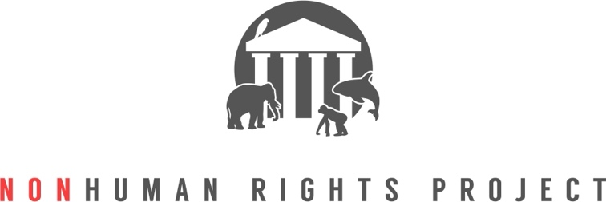
Staff Bios (organized alphabetically by last name)
Lauren Choplin is the NhRP’s Communications Director. She received an M.A. in English from Rutgers University in 2014, an M.F.A. in Creative Writing from the University of Alabama in 2010, and a B.A. in English with a minor in International Relations from the University of Southern California in 2004. In graduate school, Lauren’s research focused on critical animal studies, narrative empathy, and theories of resistance and social change.
Peggy Cusack is the NhRP’s Chief Operating Officer, overseeing our day-to-day activities and internal organizational operations. Prior to joining the NhRP, Peggy worked at several high-profile nonprofit organizations and owned her own consulting business, supporting clients with strategic planning, organizational capacity building, coalition development, and campaign management for twenty years. Peggy holds a J.D. from the University of Virginia, an M.A. in communications from American University, and a B.A. in political science from the State University of New York.
Jake Davis is a Colorado-licensed, Montana-based Staff Attorney with the NhRP. He is the lead attorney for the NhRP's California litigation. Previously, Jake worked in federal court (under the Honorable S. James Otero of the United States District Court for the Central District of California), for the U.S. government (at the United States Attorney's Office for the Southern District of California), and in private practice (Squire Patton Boggs). Along with his work at the NhRP, Jake clerks part-time for Montana's 11th Judicial District Court. He holds a J.D. from Loyola Law School, Los Angeles, and a B.A. from Emory University in Atlanta, Georgia. He is a proud human to a rescued pitbull dog named Archie.
Courtney Fern is the NhRP’s Director of Government Relations and Campaigns. She previously served as the California State Director for The Humane Society of the United States, where she oversaw the organization’s legislative and grassroots advocacy in the state, and as Campaigns Director for an international animal rights organization. She has also organized volunteers and events for political campaigns. Upon graduation from Arizona State University, Sandra Day O’Connor College of Law in 2011, she completed a legal fellowship at the Natural Resources Defense Council. Courtney received a B.A. in Political Science and Psychology from the University of Southern California in 2008.
Spencer Lo is a Senior Staff Attorney with the NhRP. He earned his law degree from the Elisabeth Haub School of Law at Pace University in 2012, when he began learning about and then volunteering with the NhRP. He holds an M.A. and B.A in philosophy from the State University of New York at Binghamton.
Monica Miller is a Senior Staff Attorney with the NhRp. She graduated cum laude from Vermont Law School in 2012 and holds an M.A. in Public Administration for Environmental Science and Policy from Columbia University and a B.A. in Environmental Studies from Pitzer College. Monica is also Senior Counsel with the American Humanist Association, where she litigates First Amendment cases across the country. Monica has presented oral arguments before the U.S. Supreme Court, as well as the U.S. Courts of Appeals for the Fourth Circuit (twice), Fifth Circuit, and Eleventh Circuit.
Shirley Shtiegman is the NhRP’s International Coordinator. She works with lawyers from around the world to research the best possible legal path to establishing actual legal rights for nonhuman animals on a country-by-country basis. Shirley is a solo practitioner in Palo Alto, CA, where she focuses on corporate, IP and commercial transactions. Shirley previously served as General Counsel of a San Francisco Bay Area tech company and has long been involved in animal advocacy and volunteered with various animal advocacy organizations in California, Washington, and Israel. Shirley earned her L.L.M. in Israel and is admitted to the bars of New York and Israel.
Elizabeth Stein is the NhRP’s New York counsel and an NhRP staff attorney. She is a solo practitioner with an office in New Hyde Park, NY, where she focuses exclusively on legal issues pertaining to animal rights, welfare, legislation, and advocacy. Liz holds a J.D. from St. John’s University School of Law and a B.S. in German from the State University of New York at Albany where she graduated Phi Beta Kappa and summa cum laude.
Amanda Waxman is a communications professional and animal advocate living in Pittsburgh, PA. Before joining the Nonhuman Rights Project as Digital Coordinator, she worked at The Humane League, a global nonprofit dedicated to ending the abuse of animals raised for food. She has also worked with grassroots climate activist groups in her city, and volunteered at several animal sanctuaries. When she’s not working, she enjoys taking part in races with her local running club and hanging out with her dog, Archie.
Steven M. Wise is founder and president of the NhRP. He began his mission to gain rights for nonhuman animals in 1985. He holds a J.D. from Boston University Law School and a B.S. in chemistry from the College of William and Mary. He has practiced animal protection law for four decades and is admitted to the Massachusetts Bar. Professor Wise taught the first class in “Animal Rights Law” at the Harvard Law School and has taught “Animal Rights Jurisprudence” at the Stanford Law School, as well as the University of Miami, St. Thomas, and John Marshall Law Schools, and is currently teaching “Animal Rights Jurisprudence” at the Lewis and Clark Law School and Vermont Law School. He is the author of four books: Rattling the Cage – Toward Legal Rights for Animals; Drawing the Line – Science and the Case for Animal Rights; Though the Heavens May Fall – The Landmark Trial That Led to the End of Human Slavery; and An American Trilogy – Death, Slavery, and Dominion Along the Banks of the Cape Fear River. His TED TALK from the TED2015 Conference in Vancouver, Canada was released in May of 2015 and has over one million views.

